HTML/CSS – First implementation – Exercise 1

<html>

<head>

    <h1>Hello World, Exercise 1: First Implementation</h1>

</head>

<h1><u>Basic, List</u></h1>

<body>

    <h1>Title h1</h1>

    <h2>Title h1</h2>

    <h3>Title h3</h3>

    <h4>Title h4</h4>

    <h5>Title h5</h5>

    <h6>Title h6</h6>

    <p>Paragraph</p>

    <p><b>Bold</b></p>

    <p><strong>Strong</strong></p>

    <p><i>Italic</i></p>

    <p><em>em</em></p>

    <p><u>Underline</u></p>

    <p><strike>Strikethrough</strike></p>

    <p><sup>2</sup></p>

    <p><sup>2</sup></p>

    <!--https://unicode-table.com.en.00A9-->

    <p>Copyright &#169; 2020</p>

    <p>

        <blockquote>Học, học nữa, học mãi.

            <cite>&mdash; Lê-nin</cite>

        </blockquote>

    </p>

    <p>

        <address>KP6, Linh Trung, Thủ Đức, HCM.</address>

    </p>

</body>

<body>

    <ul>

        <p>Danh sách website:</p>

        <li><a href="http://uit.edu.vn/"target="_blank">UIT</a></li>

        <li>SE</li>

        <li>Website môn học UIT</li>

    </ul>

    <ol>

        <p>Danh sách website:</p>

        <li><a href="http://uit.edu.vn/"target="_blank">UIT</a></li>

        <li>SE</li>

        <li>Website môn học UIT</li>

    </ol>

</body>

<body>

    <a href="httpL//fb.com/">Facebook</a>

    <a href="http://uit.edu.vn/" target="_blank"></a>

    <br>

    <a href="http://www.facebook.com/profile.php" target="blank">

        <img src="fb-cover.jpg" alt="fb-cover" title="fb-cover" width="" height="">

    </a>

</body>

<h1><u>Table</u></h1>

<body>

    <table border="1">

        <tr>

            <th>STT</th>

            <th>Họ tên</th>

            <th>Lớp</th>

        </tr>

        <tr>

            <td>1</td>

            <td>Nguyễn Văn A</td>

            <td>PMCL</td>

        </tr>

        <tr>

            <td>2</td>

            <td>Nguyễn Văn B</td>

            <td>KTPM</td>

        </tr>

        <tr>

            <td>3</td>

            <td colspan="2">None</td>

        </tr>

    </table>

    <br>

    <table border="1">

        <tr>

            <th>STT</th>

            <th>1</th>

            <th>2</th>

        </tr>

        <tr>

            <td>3</td>

            <td colspan="2">None</td>

        </tr>

    </table>

    <br>

    <table border="1">

        <tr>

            <th>STT</th>

            <th>1</th>

            <th>2</th>

            <td>3</td>

        </tr>

        <tr>

            <th>Họ tên</th>

            <td>Nguyễn Văn A</td>

            <td>Nguyễn Văn B</td>

            <td rowspan="2">None</td>

        </tr>

        <tr>

            <th>Lớp</th>

            <th>PMCL</th>

            <th>TMCL</th>

        </tr>

    </table>

</body>

<h1><u>Form</u></h1>

<head>

    <title>HTML5</title>

</head>

<body>

    <form action="" method="GET" accept-charset="UTF-8">

        <!--action: java script

            method: Get/POST/PUSH/PATCH/DELETE-->

            <label for="full-name">Họ và tên:</label>

            <input type="text" name="full-name" value="" placeholder="Họ và Tên">

            <label for="about-your-self">Mô tả về bạn thân:</label>

            <textarea name="about-your-self" id="" cols="30" rows="10"></textarea>

            <button>Xóa dữ liệu</button>

            <input type="submit" value="Gửi dữ liệu">

            <!--

            Type: color/checkbox/date/datetime/datetime-local/email/file/hidden/

                image/month/number/password/radio/range/reset/search/tel/time/url/week

            -->

            <select name="" id="">

                <optgroup label="UIT">

                    <option value="">DAA</option>

                    <option value="">Website môn học</option>

                </optgroup>

                <optgroup label="Mạng xã hội">

                    <option value="">FB</option>

                    <option value="">Zalo</option>

                </optgroup>

            </select>

    </form>

</body>

</html>

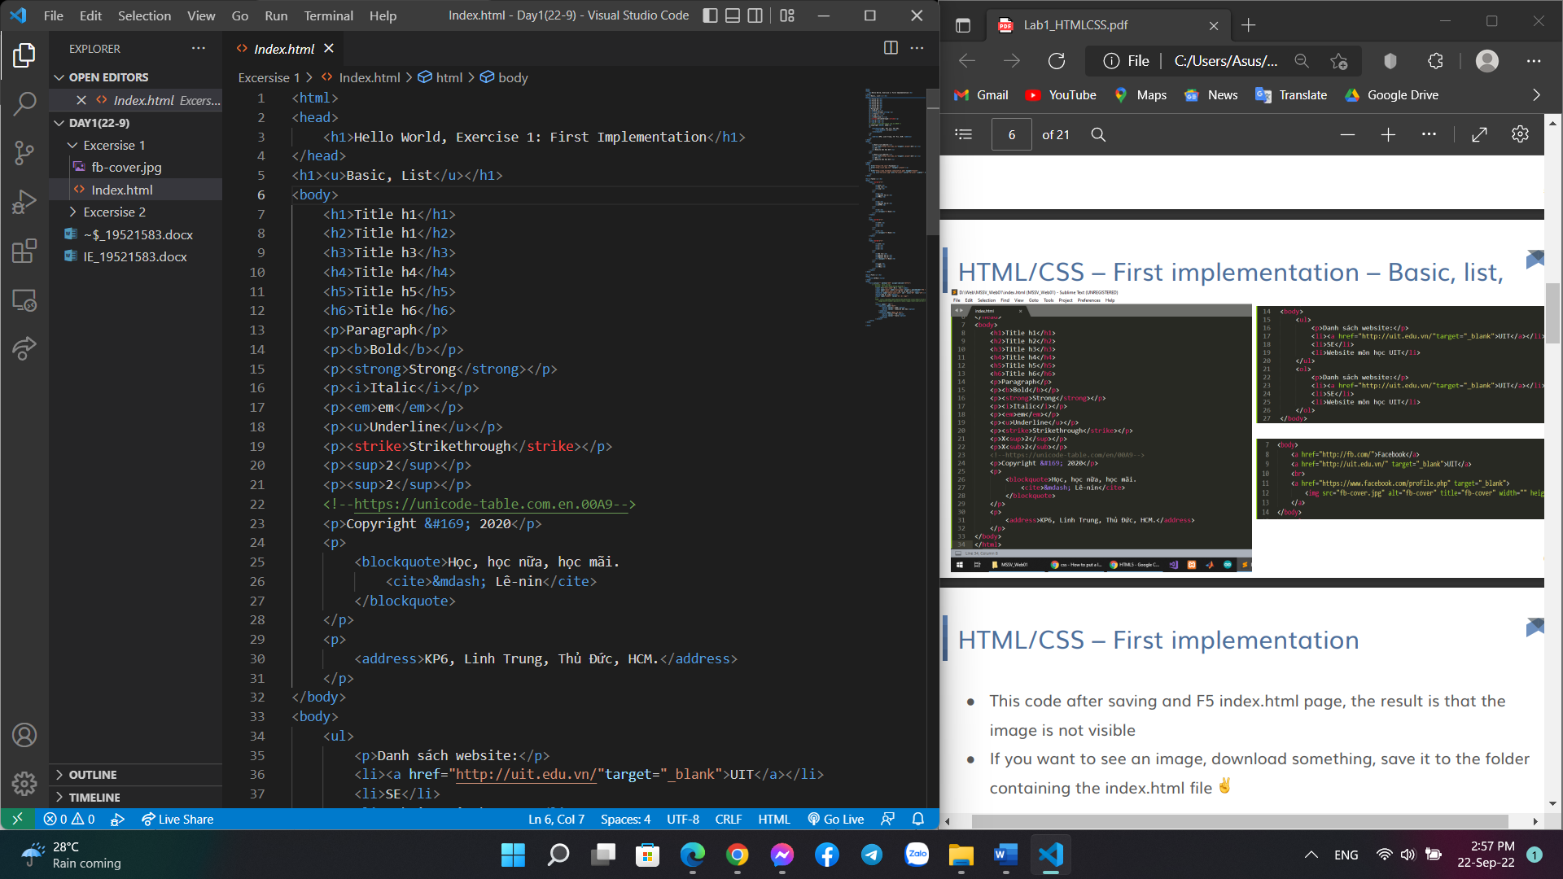

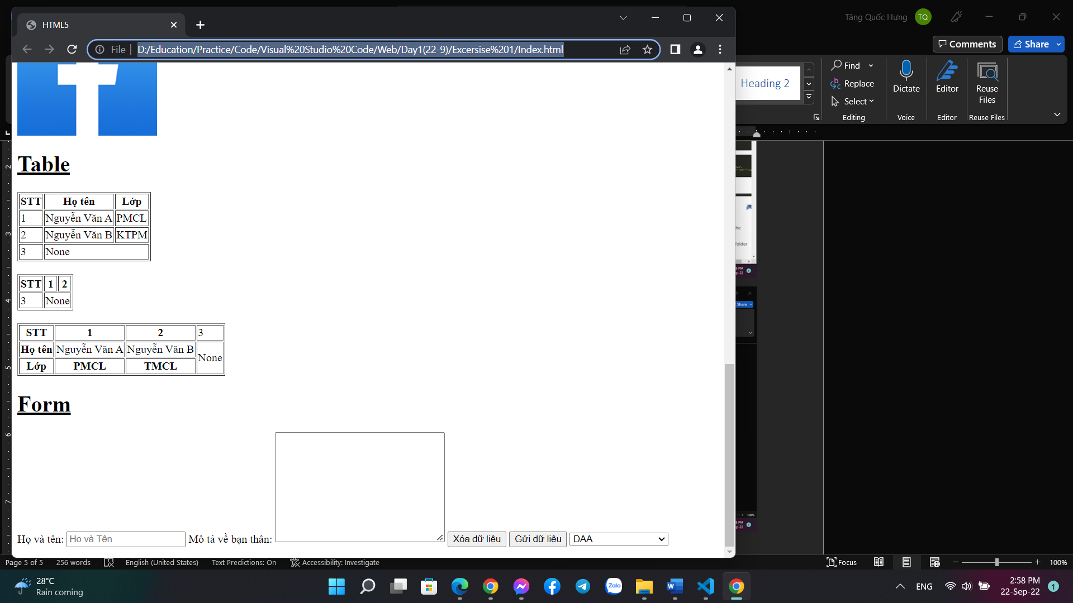

HTML/CSS – Exercise 2

<html>

<head>

    <title>Thomas H. Cormen</title>

    <link rel="SHORTCUT ICON" href="thomas h cormen.jpg">

</head>

<body>

    <table cellpadding="10" cellspacing="0">

        <tbody><tr valign="TOP">

    <p>

        <img src="thomas h cormen.jpg" alt="thomas h cormen" title="thomas h cormen" style="float:left;width:180px;height:240px;">

        <style>

            .mytitle {

               color: #000080;

            }

            .mytitle1{

               color: #0000FF;

            }

        </style>

         <td align="LEFT" valign="TOP">

            <h2 class="mytitle"><b>Thomas H.Cormen <br>Emeritus Professor <br>Department of Computer Science</b></p>

            <p class="mytitle">I retired on January 1,2022. I am no longer taking any new students or interns at any level.</h4>

            <p class="mytitle">Update June 2022: I am a Democratic candidate for the New Hampshire House of Representatives, running in Lebanon Ward 3 (Grafton County District 15). <br><a class="mytitle1" href="http://uit.edu.vn/">Campaign Website</a></h4>

            <p class="mytitle">Ph.D.,<a class="mytitle1" href="http://uit.edu.vn/">Massachusett Institute of Technology</a>, 1992</p>

            <dd>

                <b>

                    <img src="yellowsq.gif" alt="*" width="9" height="9" align="center">

                    <a href="papers.html">Papers</a>

                    <br>

                    <img src="yellowsq.gif" alt="*" width="9" height="9" align="center">

                    <a href="http://www.cs.dartmouth.edu/FG/">FG</a>

                    <br>

                    <img src="yellowsq.gif" alt="*" width="9" height="9" align="center">

                    <a href="software.html">Other software</a>

                    <br>

                    <img src="yellowsq.gif" alt="*" width="9" height="9" align="CENTER">

                    <a href="cormen-vita.pdf">Vita</a>

                </b>

            </dd>

        </td>

        </tr>

        </tbody>

    </table>

    </p>

    <hr>

    I taught my final course in Fall 2019.  You can view a <a href="https://www.youtube.com/watch?v=7uQRrNdpMsU&amp;t=1329s">video of my

    last lecture</a>, which was not about computer science.

    <hr>

    Khan Academy now carries <a href="https://www.khanacademy.org/computing/computer-science/algorithms">algorithms

    tutorials</a> for which <a href="http://www.cs.dartmouth.edu/~devin">Devin Balkcom</a> and I

    produced content.

    <hr>

    Are you looking for solutions to exercises and problems in

    <i>Introduction to Algorithms</i>?

    <p>

    If you are, then see the <a href="#solutions">frequently asked

    question and answer</a> below.

    </p><p>

    If you request solutions from me, I will not respond.

    </p><hr>

    From July 2004 through June 2008, I was the director of the <a href="https://writing-speech.dartmouth.edu">Dartmouth Institute for

    Writing and Rhetoric</a>.

    <p>

    I occasionally taught a graduate Computer Science course on how to

    write papers and how to give talks.  I publish a <a href="Cormen-rules.pdf">list of usage rules</a> that I required my

    students to observe.

    </p><hr>

    In 2015, PRI's "The World" ran a <a href="http://www.pri.org/stories/2015-06-15/women-computer-science-little-mentoring-goes-long-way">story

    on mentoring women in computer science</a> in which a couple of my

    students and I were interviewed.

    </body>

</html>

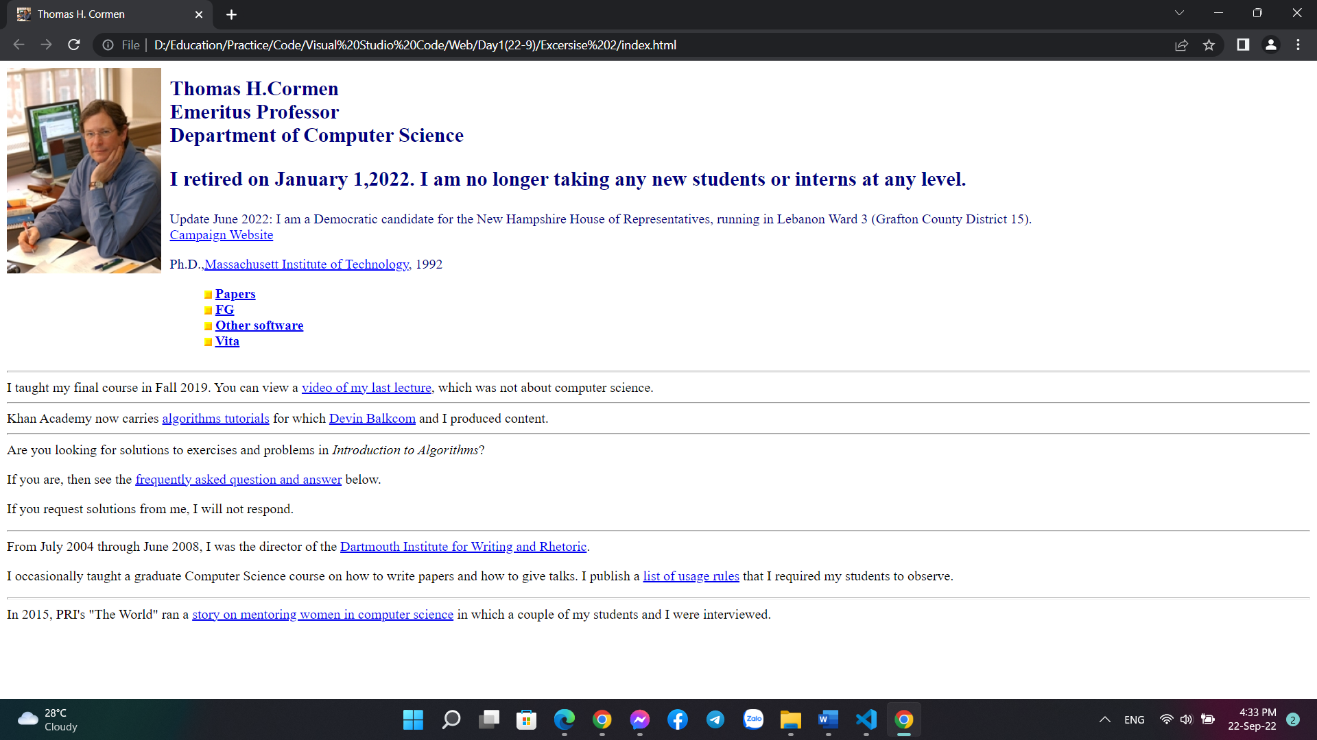

Replace with your personal information